**Date Difference Calculator**

Application has two modules:

1. REST_SERVER
2. REST_CLIENT
3. REST_SERVER

Complete logic of calculating difference between two dates has been designed and developed on Eclipse IDE Java EE using Java 8. And whole functionality has been exposed as Java RESTful web service. WS has representation for HTML,XML & JSON as well.

1. Web Service: <http://localhost:8080/REST_Server/rest/date?fdate=01/01/2000&sdate=01/01/2001>
2. Folder Structure :

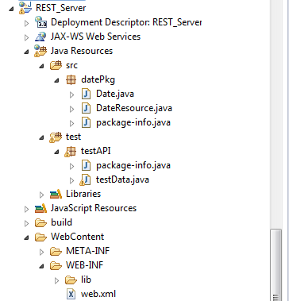

1. Web Service has been started on tomcat 7.

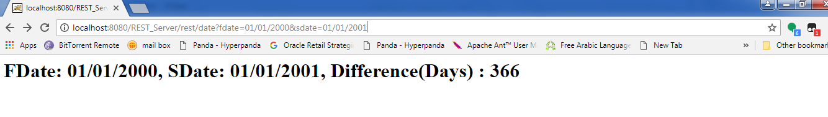

1. REST_CLIENT

Application front end has been designed to collect date range from user and find out difference in days.

Angularjs framework has been used for GUI and RESTful web service consumption.

1. Folder Structure:

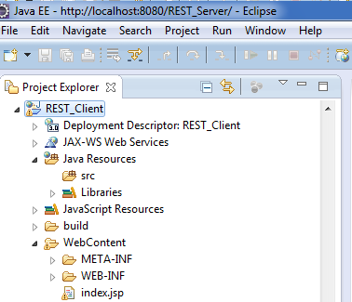

1. Front End Snapshots:

First and Second Date fields have to be entered by user and choose ‘CalcDifference’ button to get Difference (days).

**Note:** Dates should be in given format.

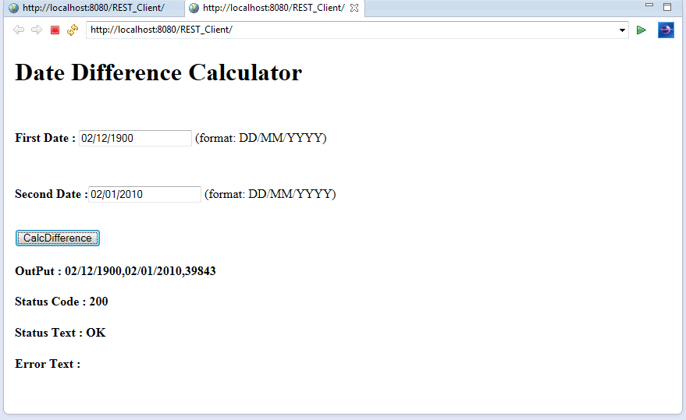

1. Along with difference, application status and error if occurred has also been tracked.

